# AI ASSISTED CODING -14.3

NAME: DARIPELLI SRIYA

ENROLLMENT NO: 2403A51350

COURSE: AI ASSISTED CODING

SPECILIZATION: CSE-AIML

DATE :28-10-2025

Task Description #1 – AI-generated HTML Page Task: Ask AI to generate a simple HTML homepage for a "Student Info

Portal" with a header, navigation menu, and footer

PROMPT:

Develop a code to generate aTask: Ask AI to generate a simple HTML homepage for a "Student Info Portal" with a header, navigation menu, and footer. Expected Output: • HTML code with <header>, <nav>, <footer>. • Clean indentation, proper tags, and comments

Expected Output:

* HTML code with <header>, <nav>, <footer>.
* Clean indentation, proper tags, and comments

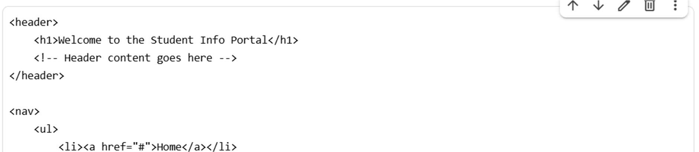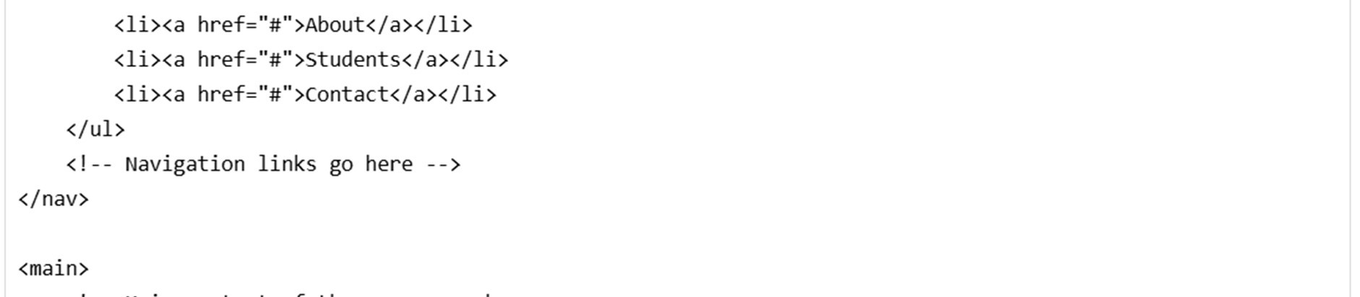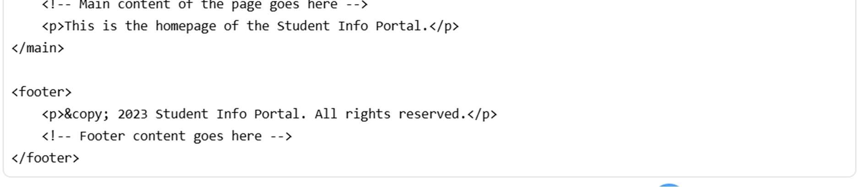

EXPLANATION:

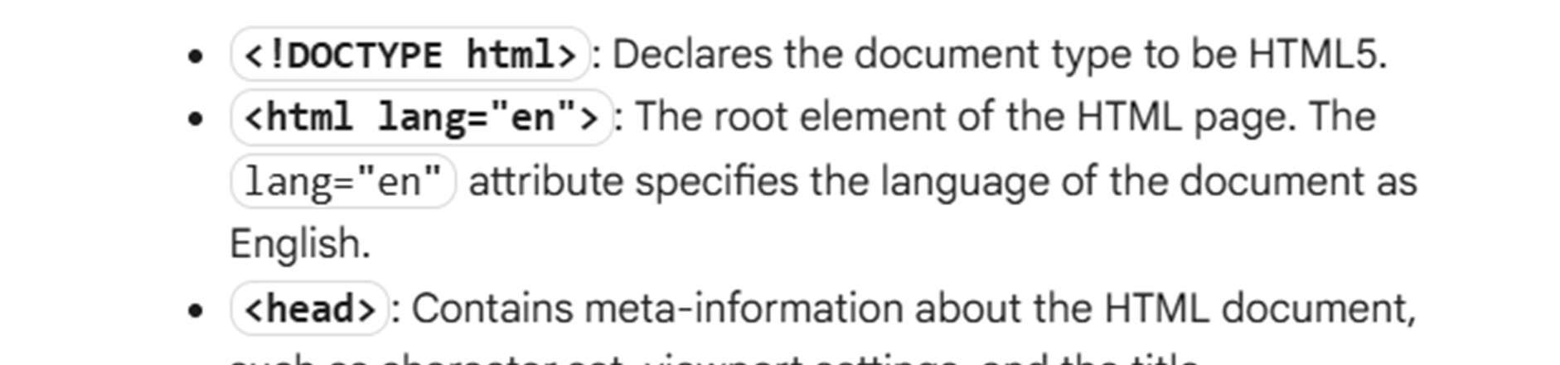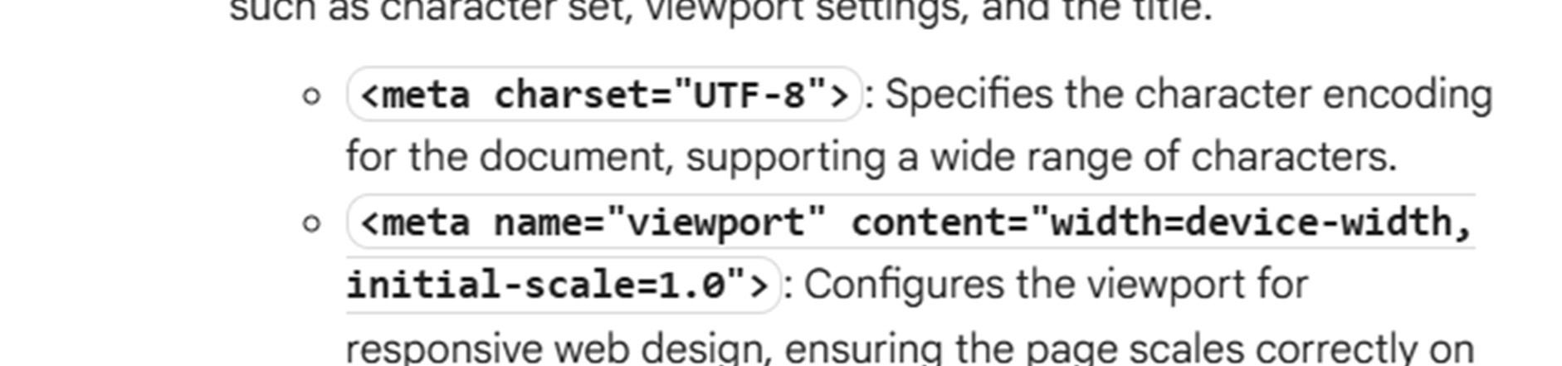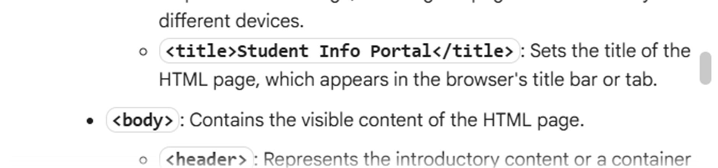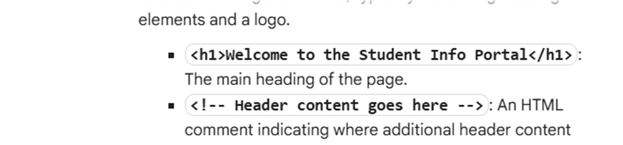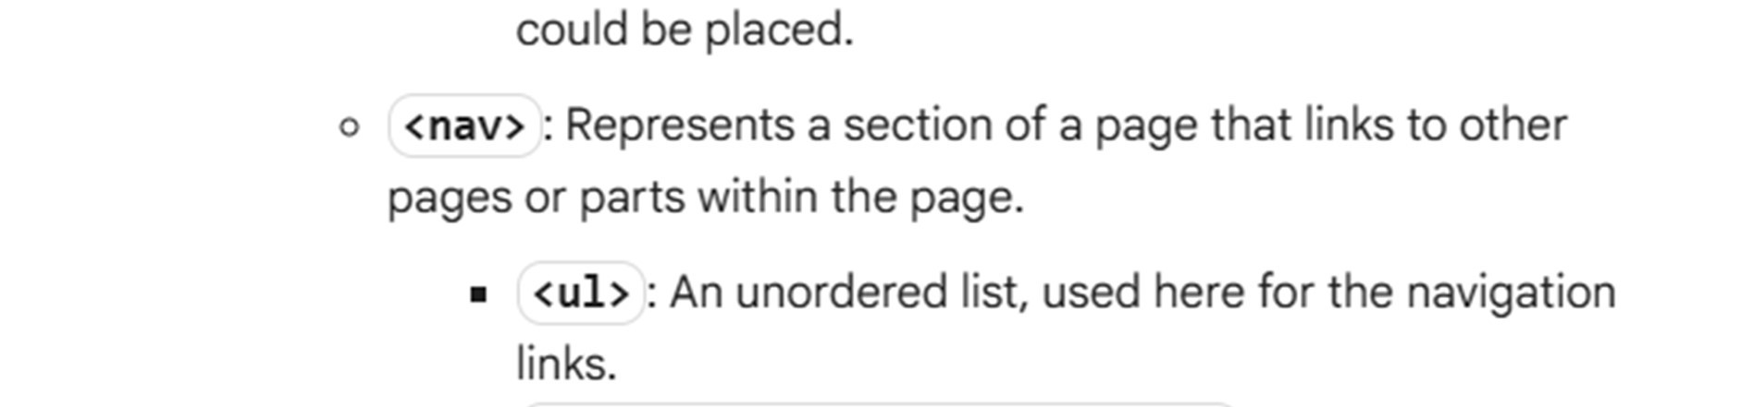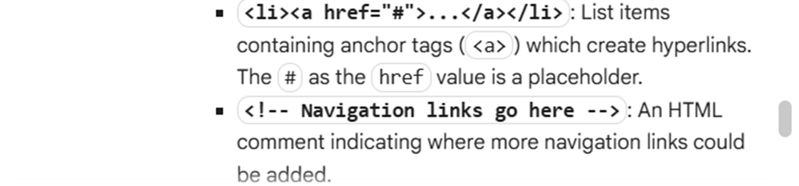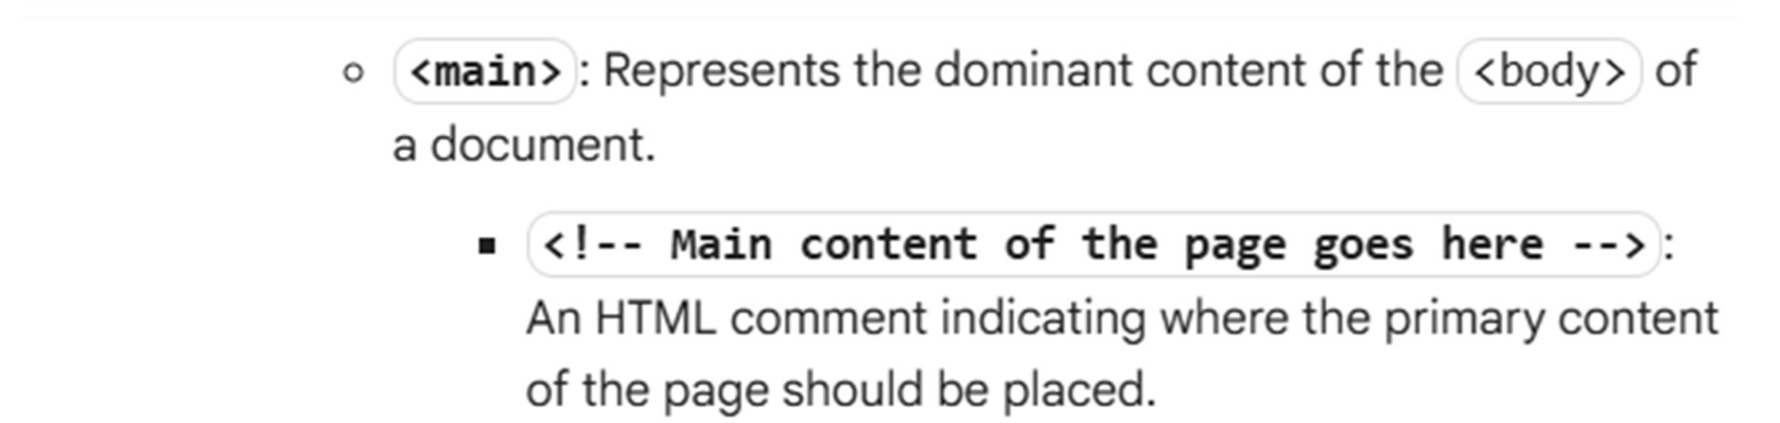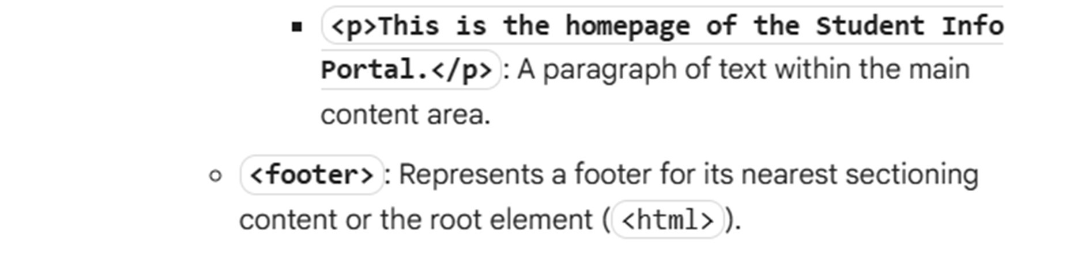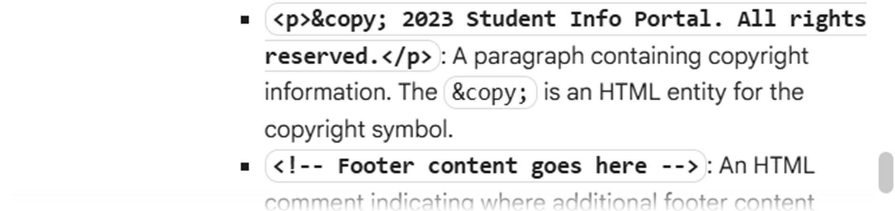

Task Description #2 – CSS Styling Task:

Use AI to add CSS styling to Task #1 homepage for:

* Responsive navigation bar.
* Centered content section.
* Footer with light gray background.

PROMPT:

Develop a python code to generate Use AI to add CSS styling to Task #1 homepage for: • Responsive navigation bar. • Centered content section. •

Footer with light gray background. Expected

Output: • HTML + CSS combined. • AI explains how

CSS classes apply

Expected Output:

* HTML + CSS combined.
* AI explains how CSS classes apply

Expected Output: AI refactors with with open() and try-except:

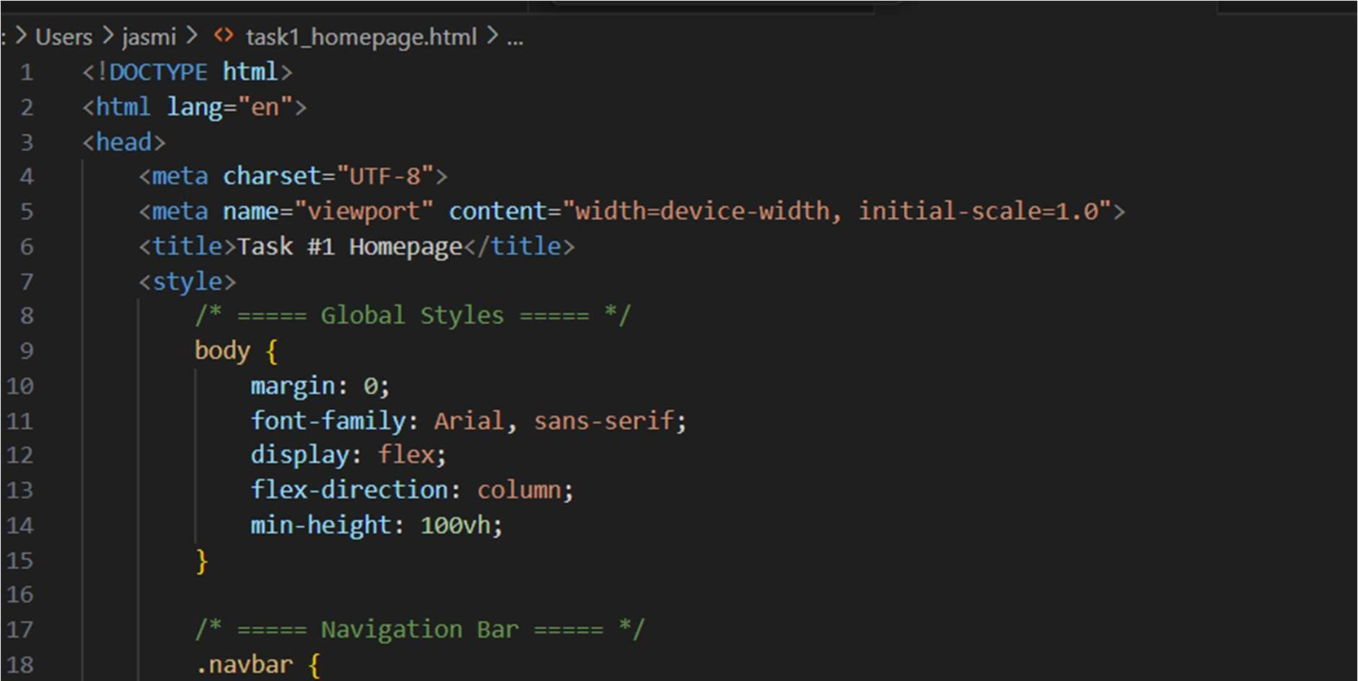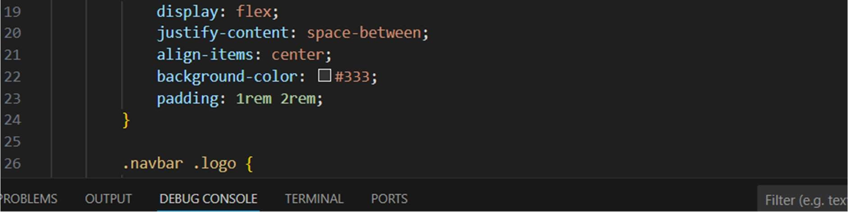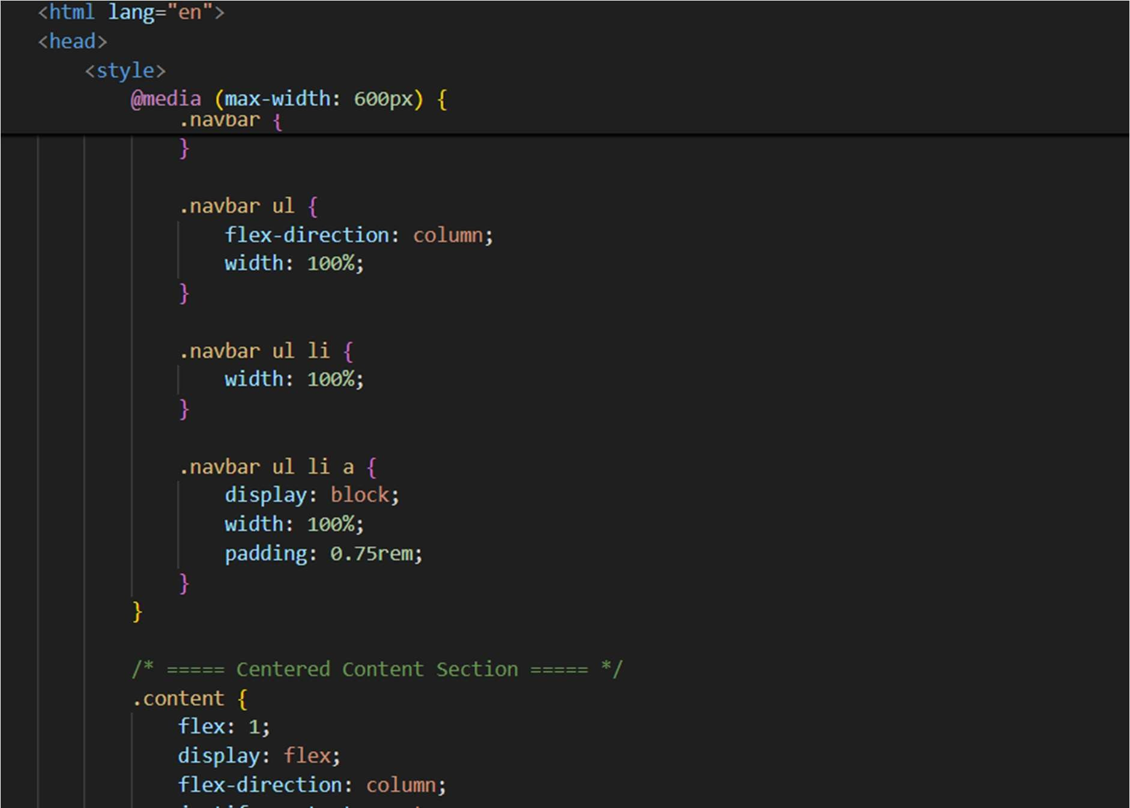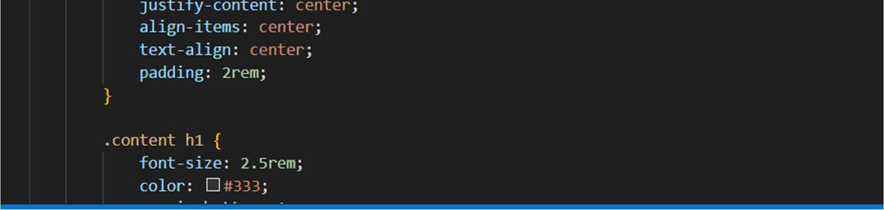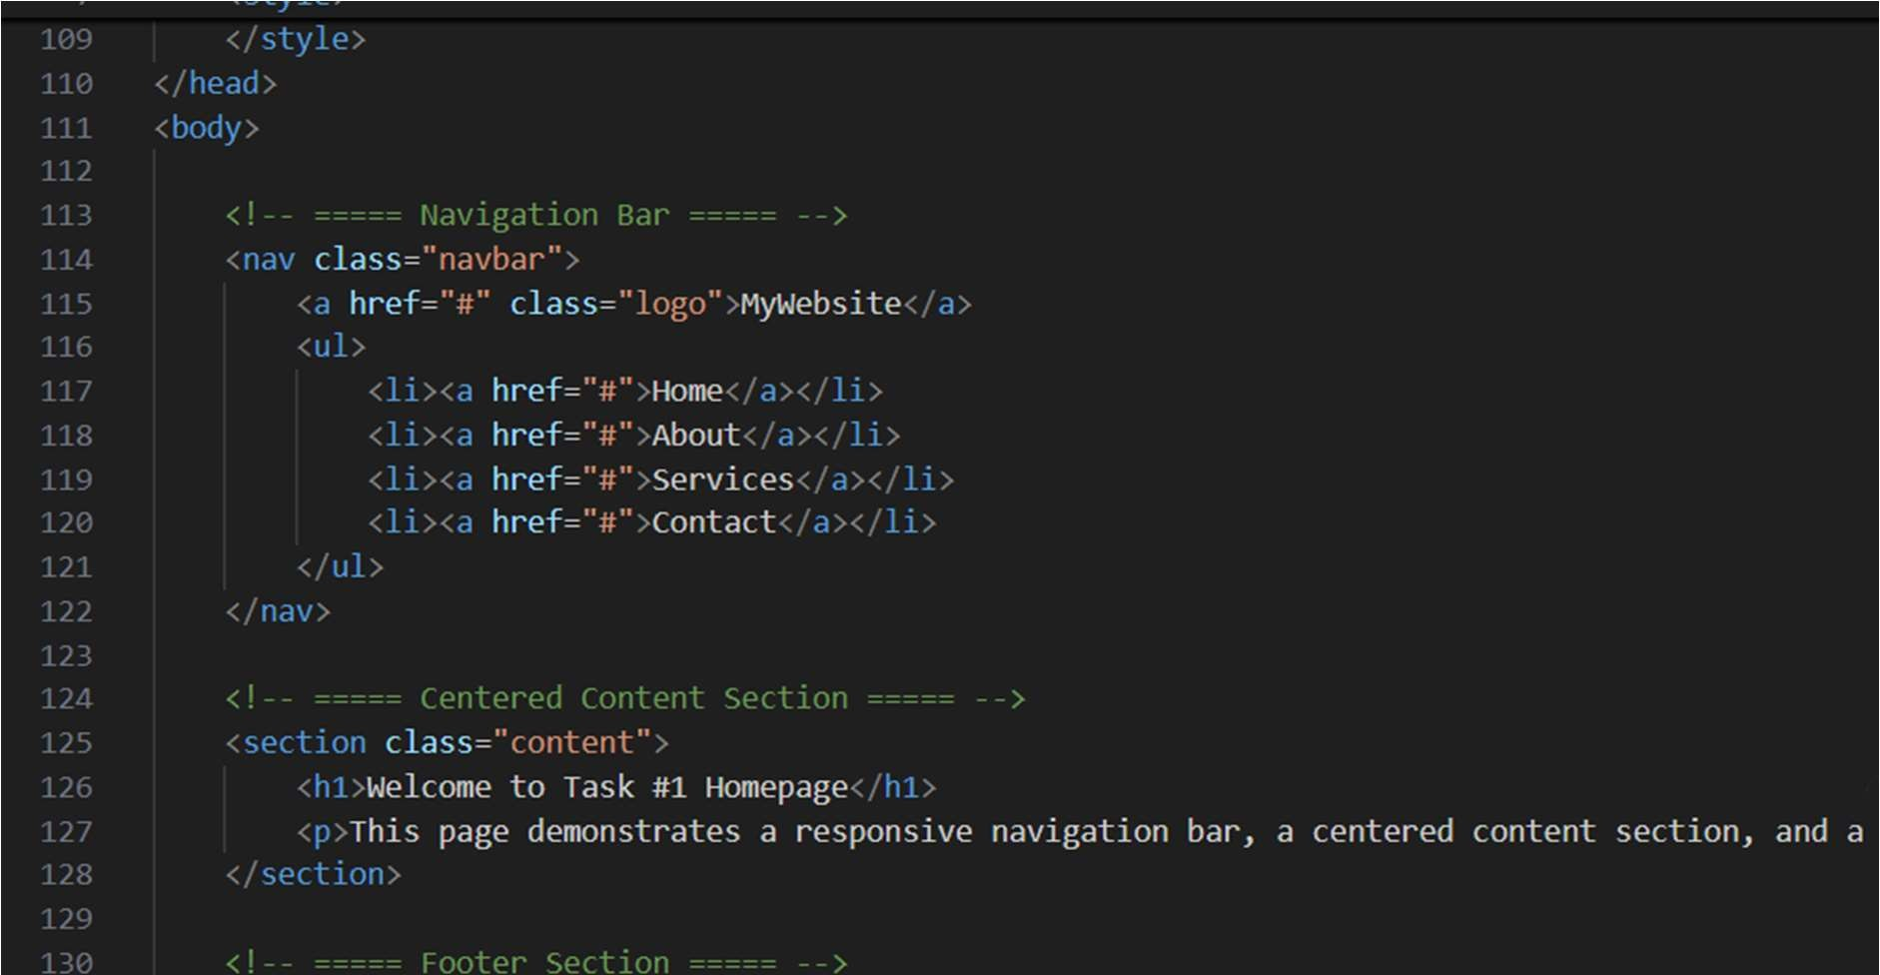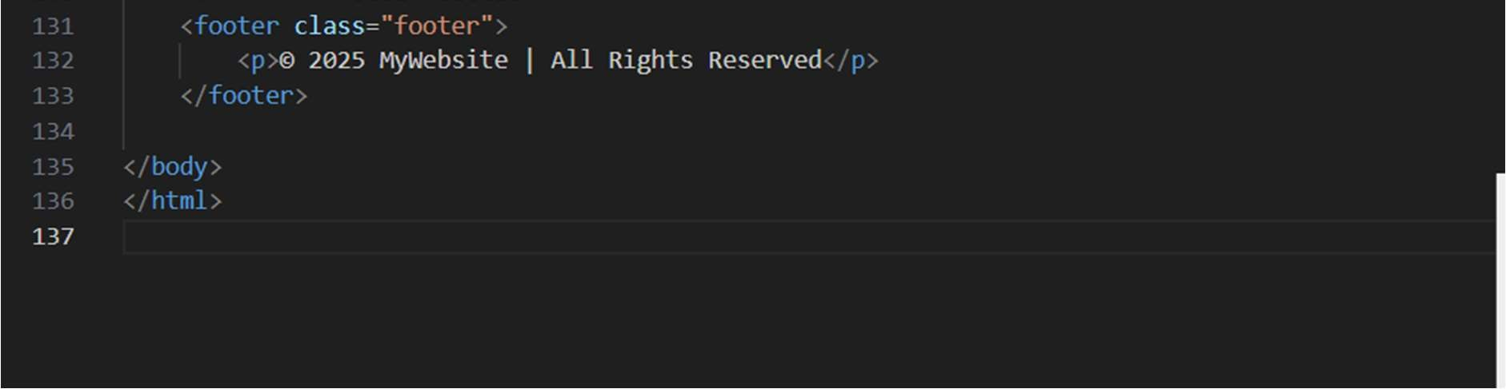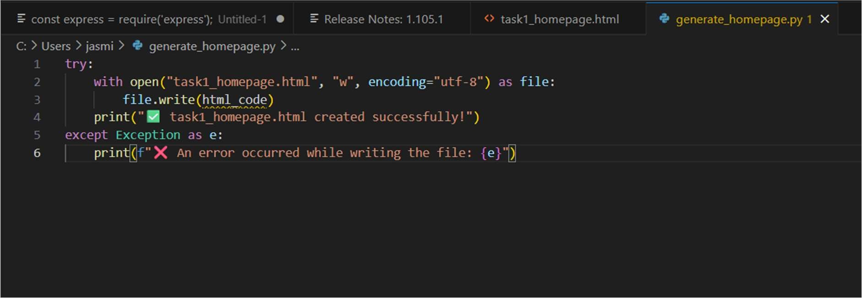

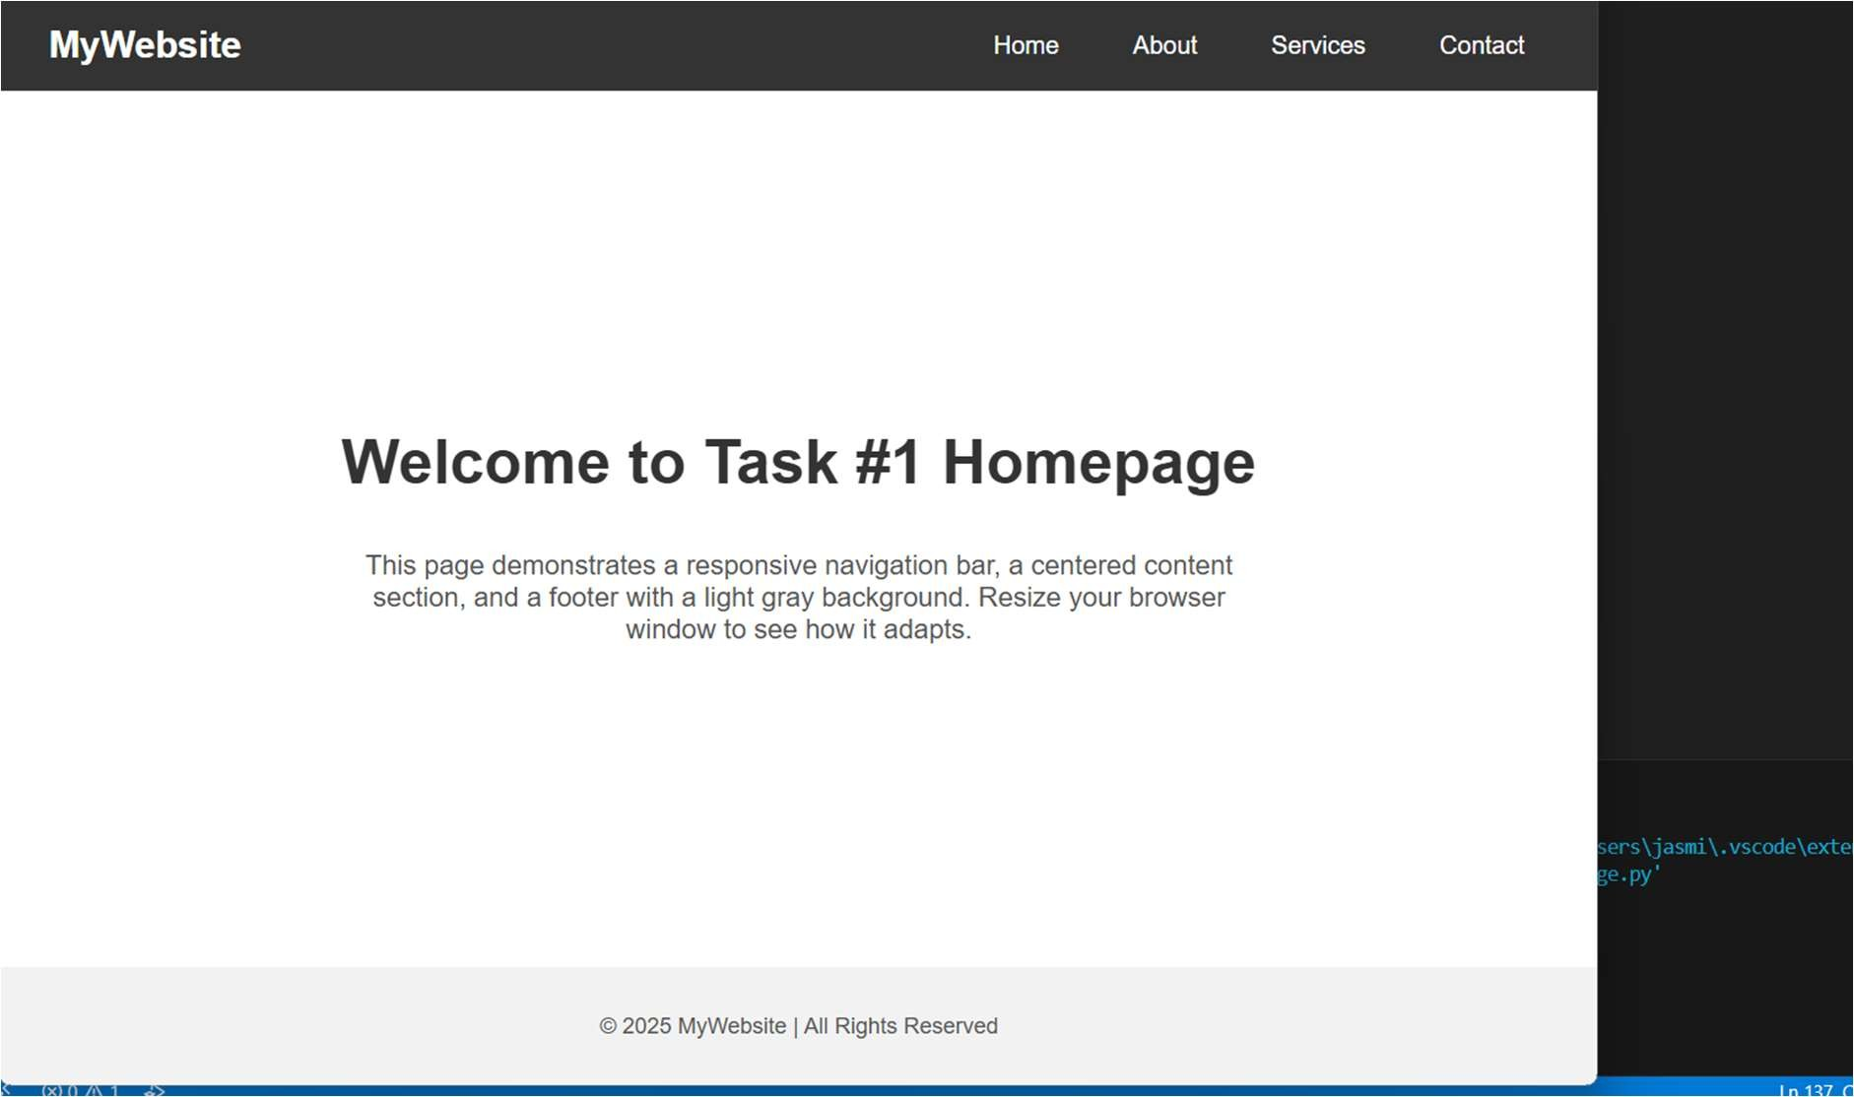

EXPLANATION :

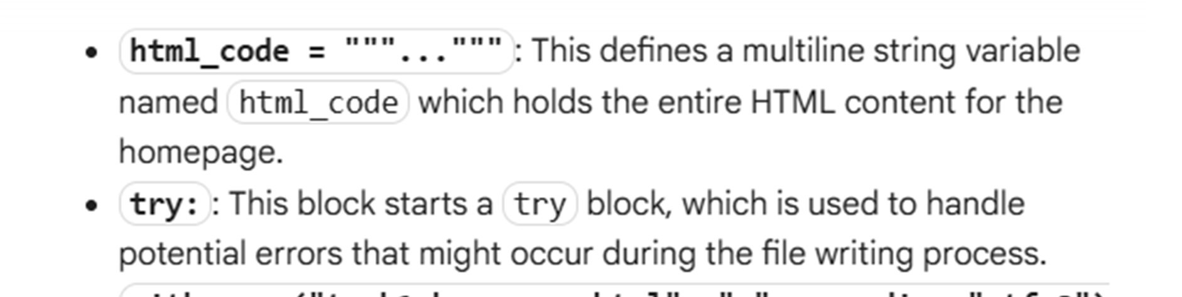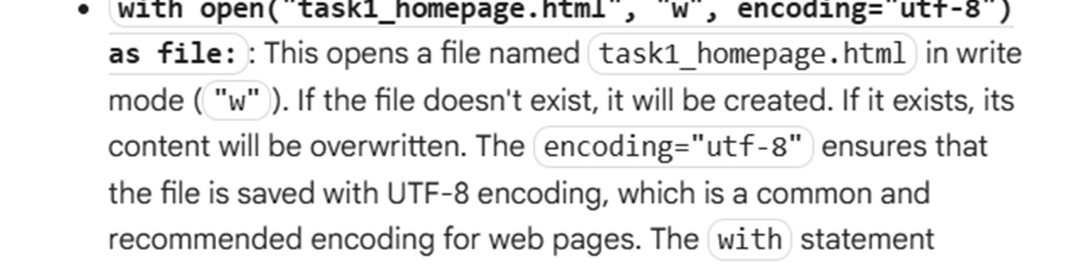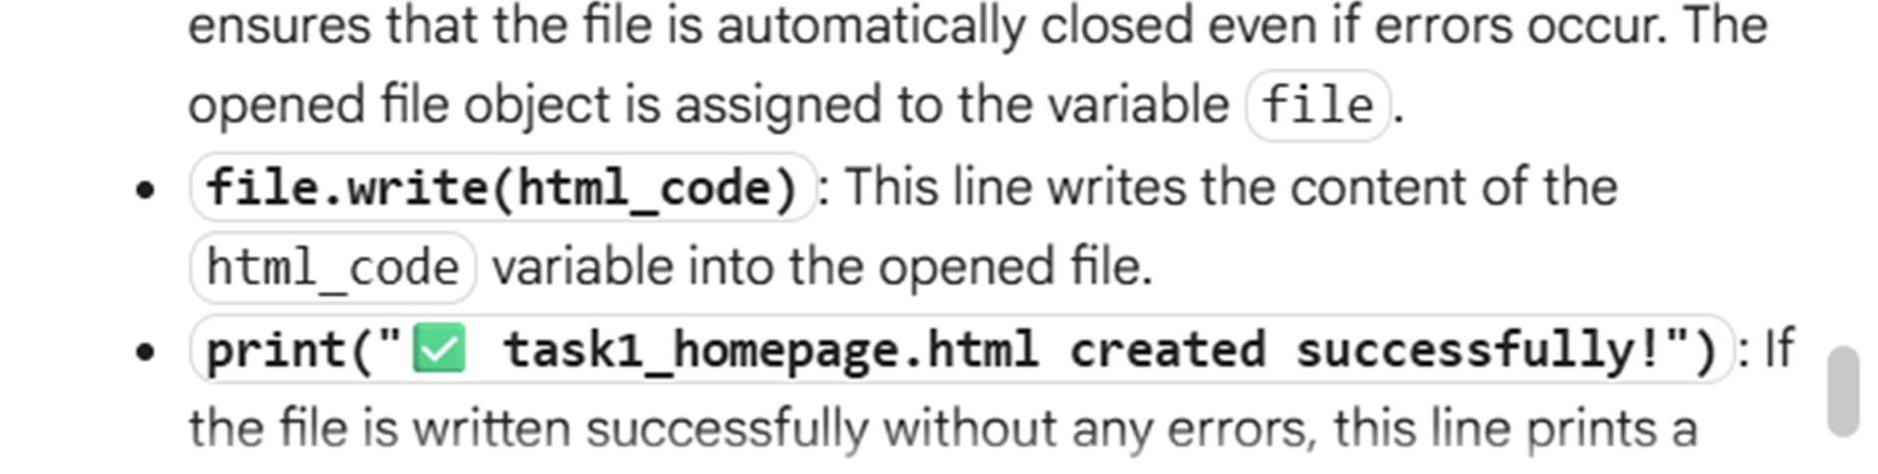

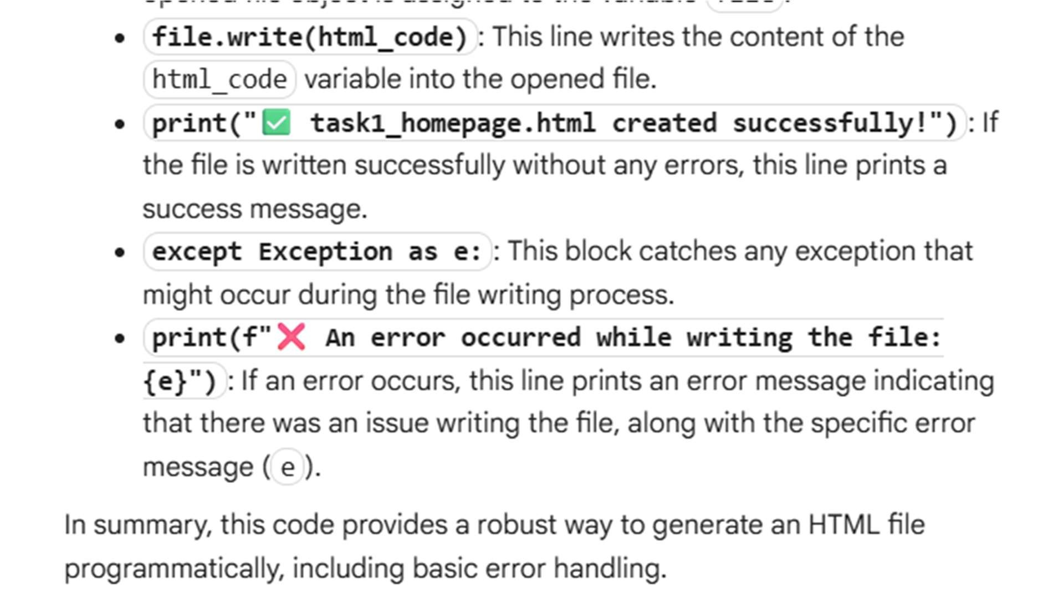

Task Description #3 – JavaScript Interactivity Task: Prompt AI to generate a JS script that validates a simple login form (non-empty username/password)

PROMPT:

Develop a code to generate Task: Prompt AI to generate a JS script that validates a simple login form (non-empty username/password). Expected Output: Working on submit JS validation. Clear error messages if inputs are empty

Expected Output:

Working on submit JS validation.

Clear error messages if inputs are empty.

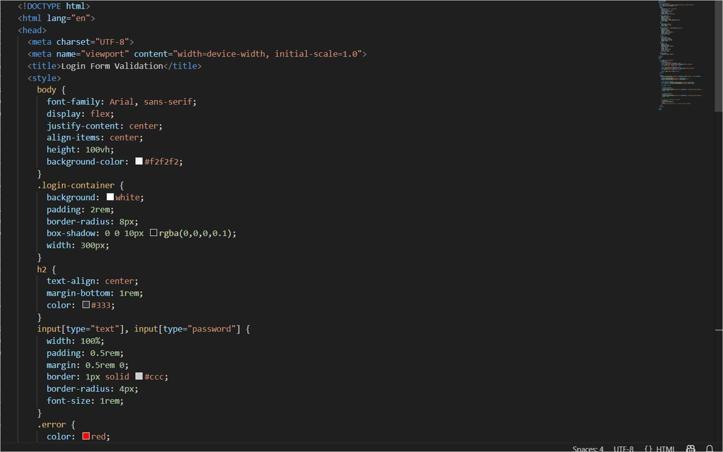

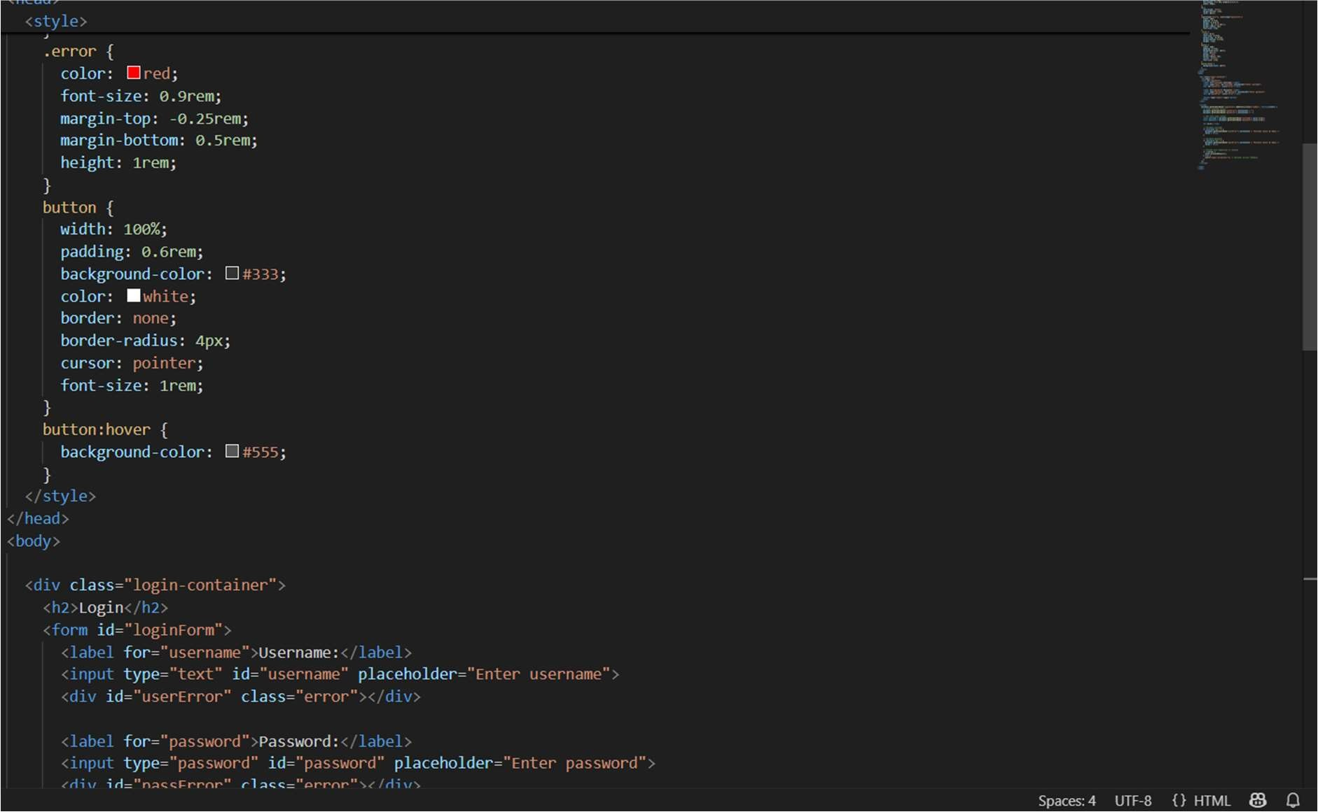

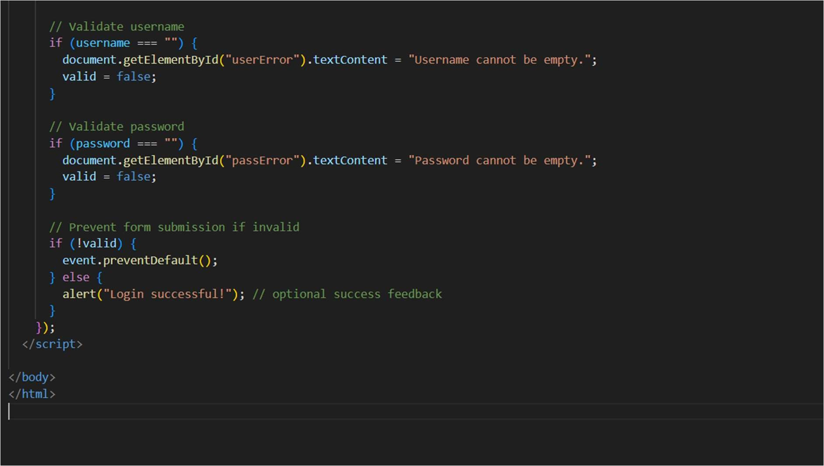

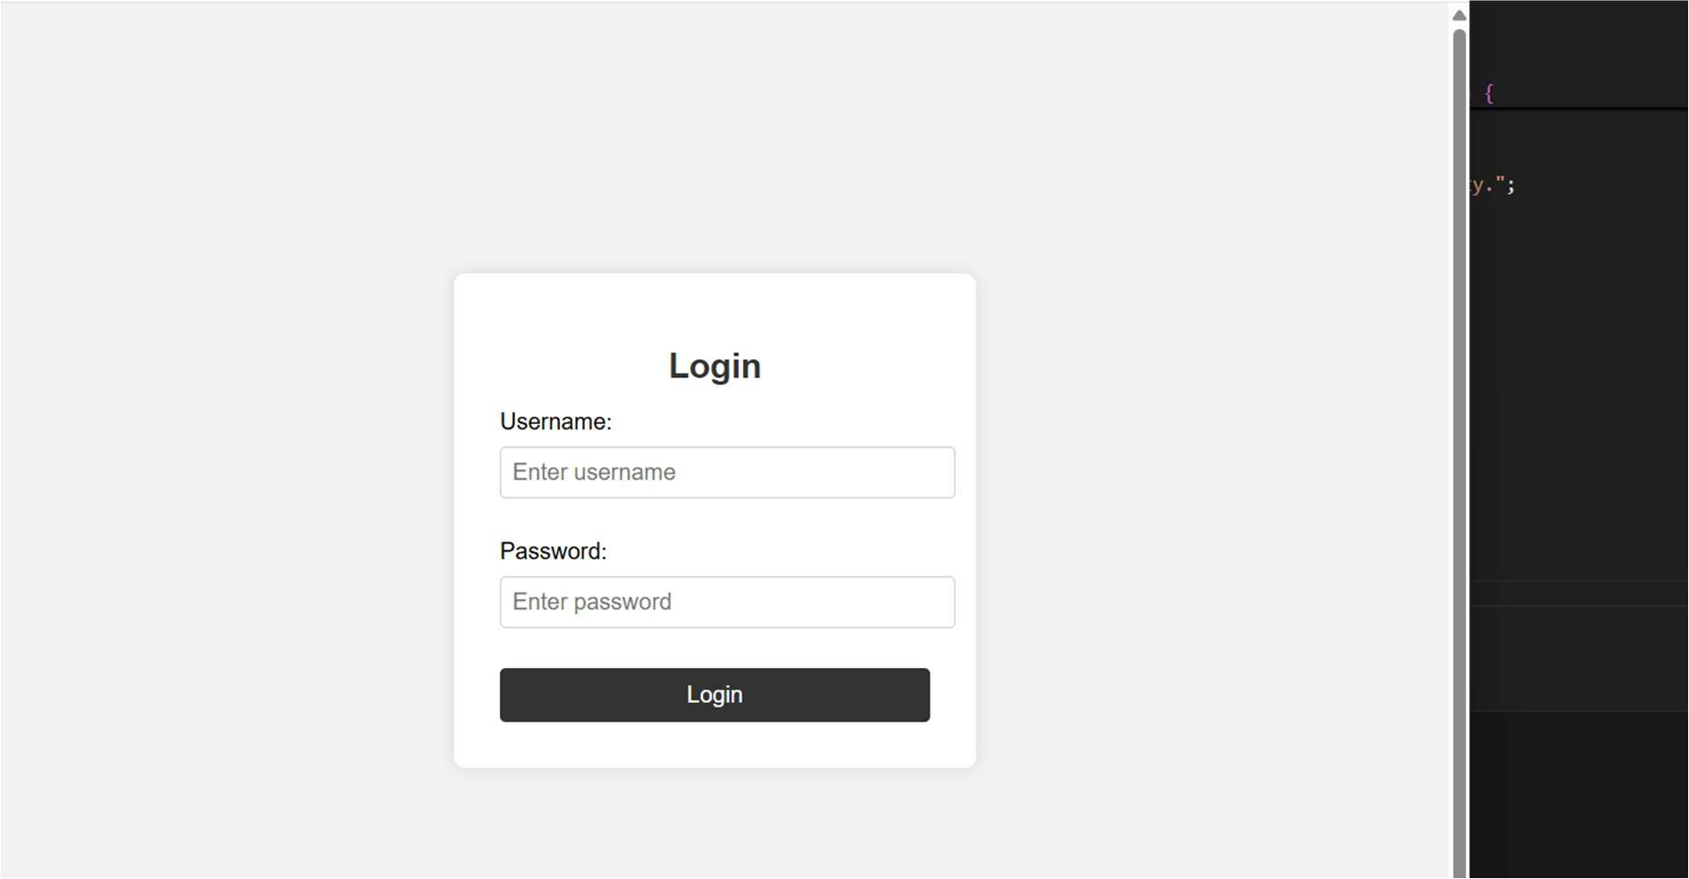

EXPLANATION:

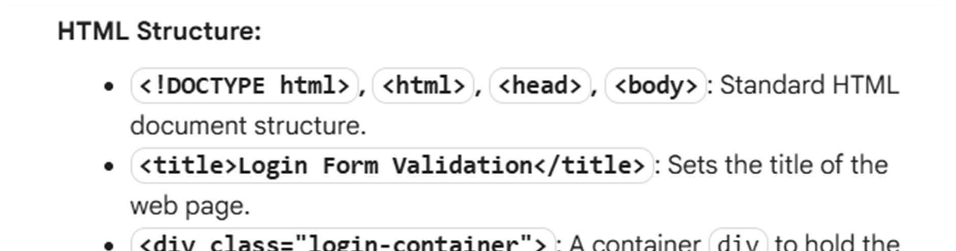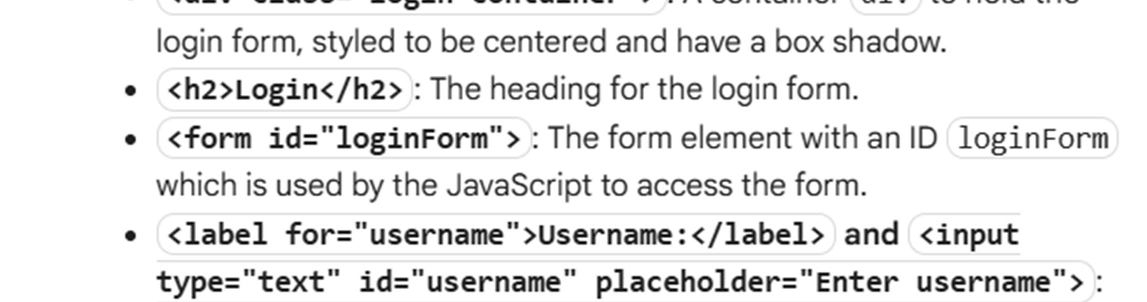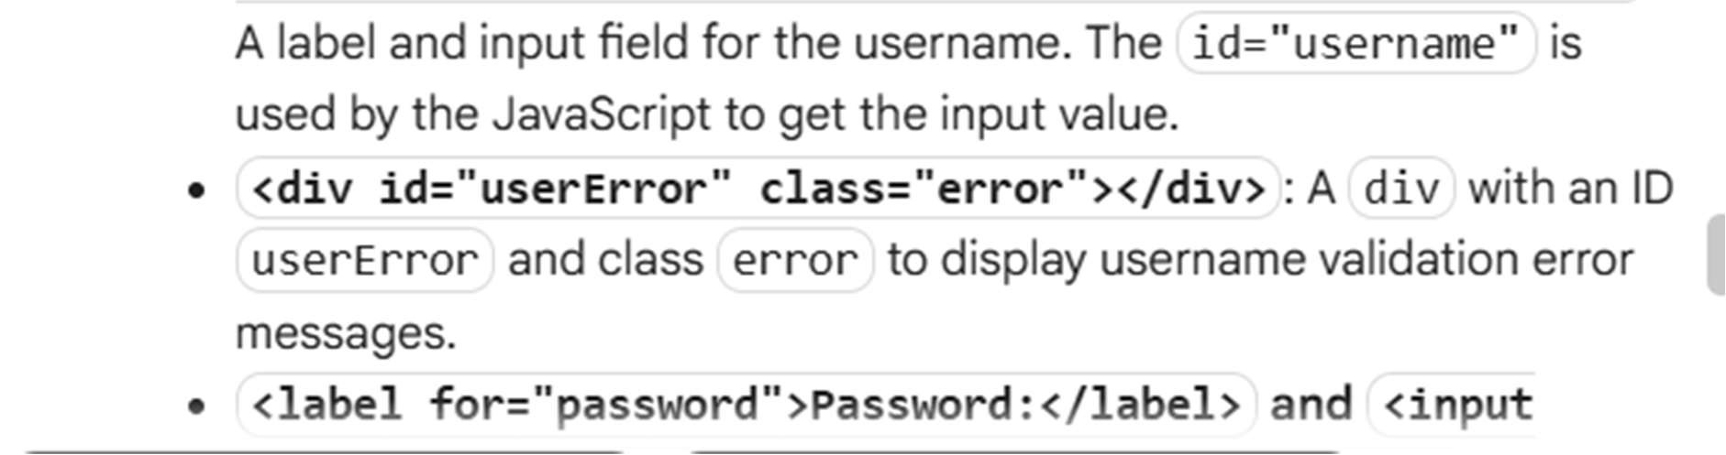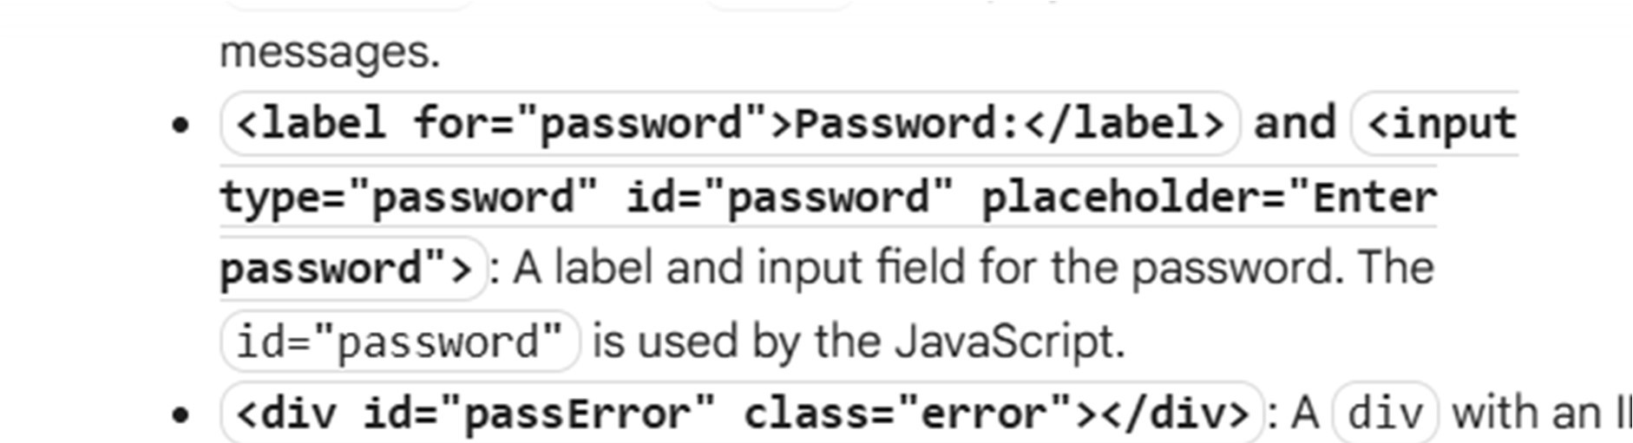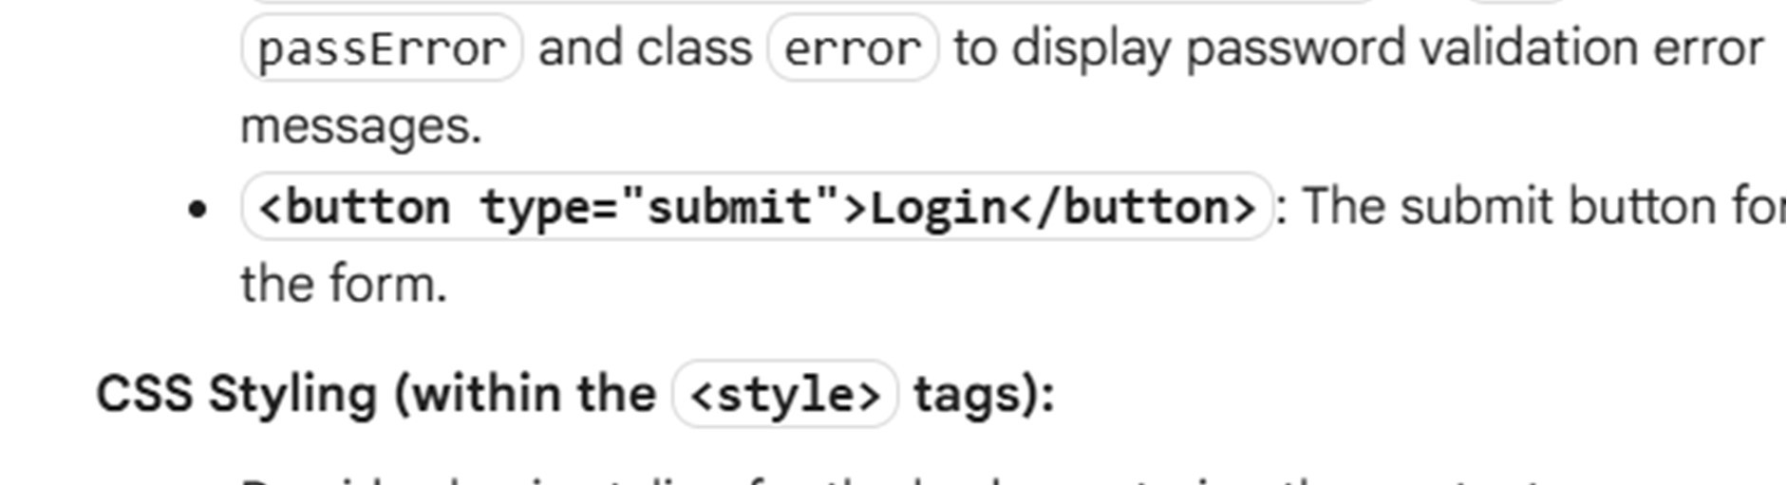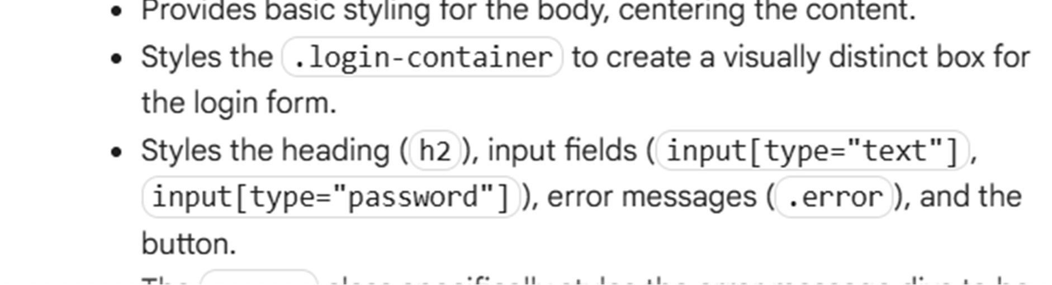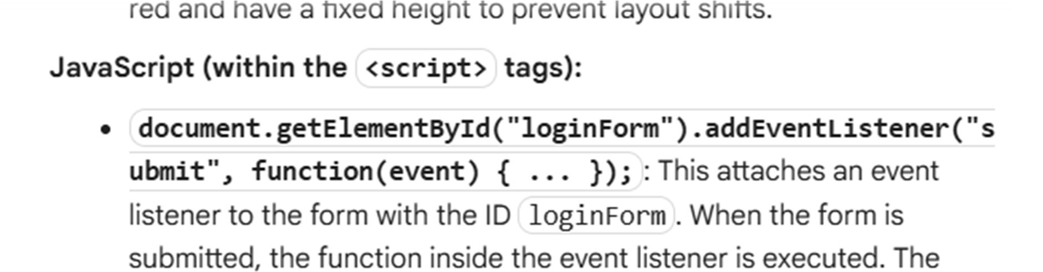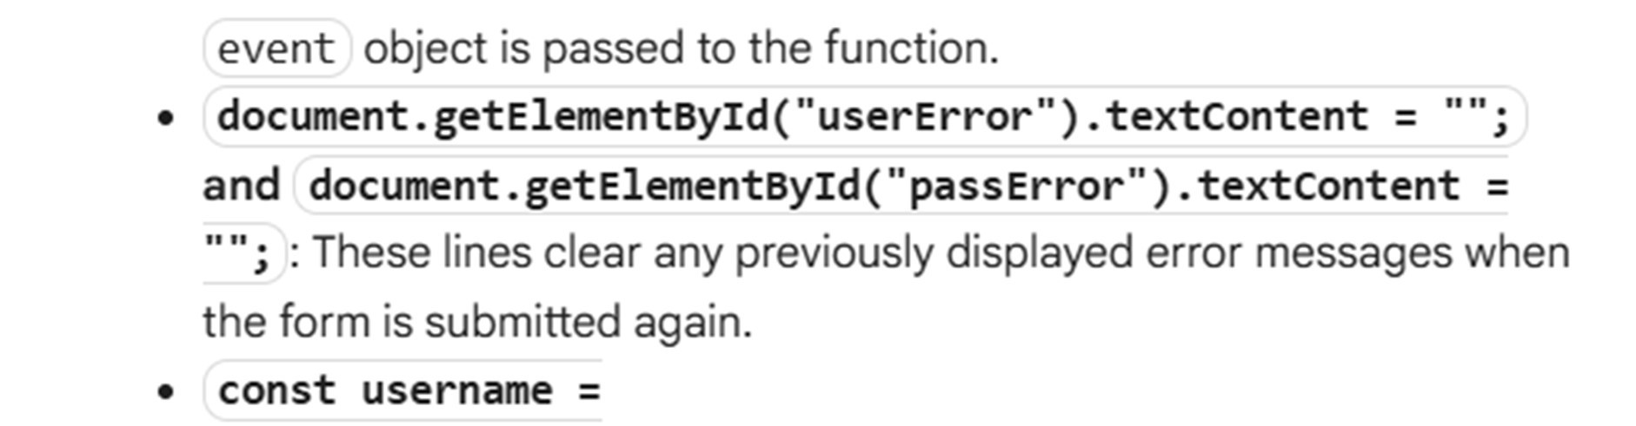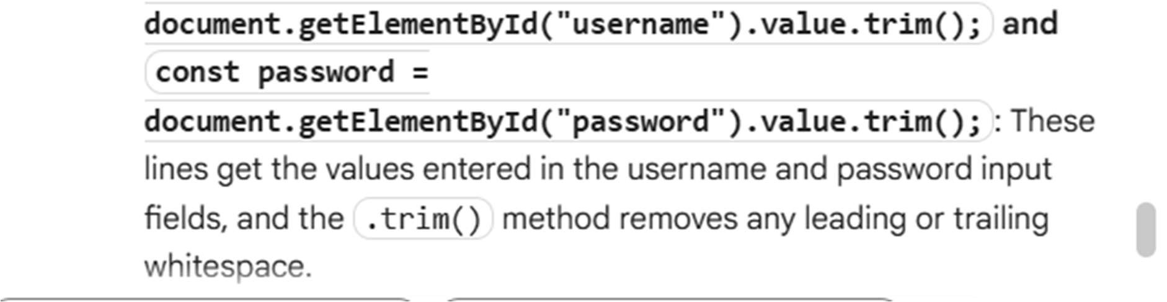

Task Description #4 – Python Backend Integration Task: Ask AI to generate a Flask app that serves the HTML form (Task

#3) and prints the username on successful login.

PROMPT:

Generate a code to develop Task: Ask AI to generate a Flask app that serves the HTML form (Task #3) and prints the username on successful login.

Expected output:

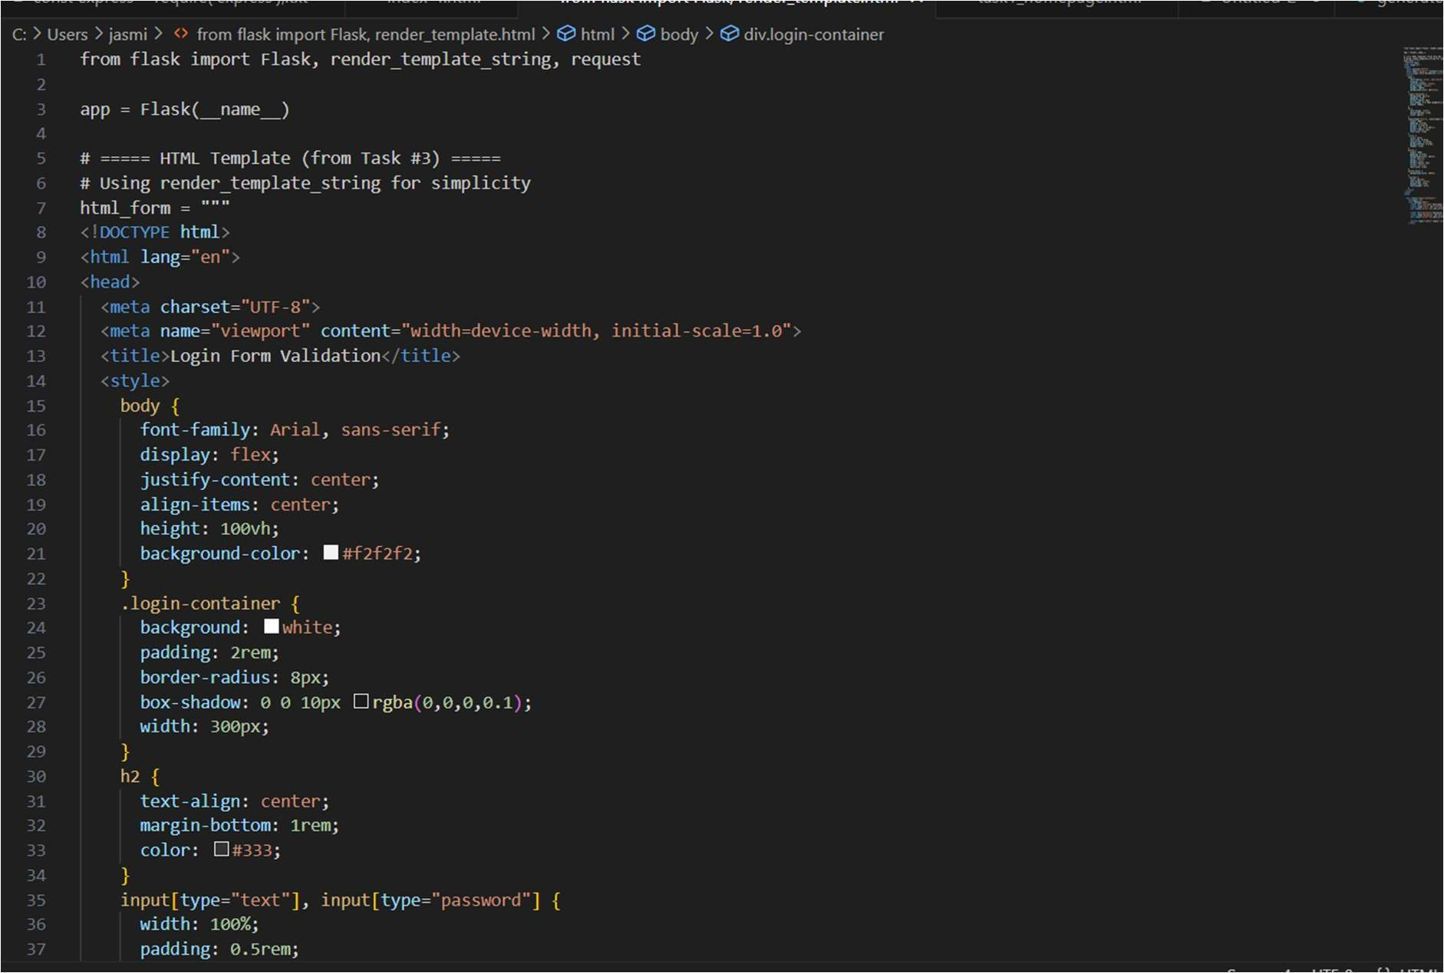

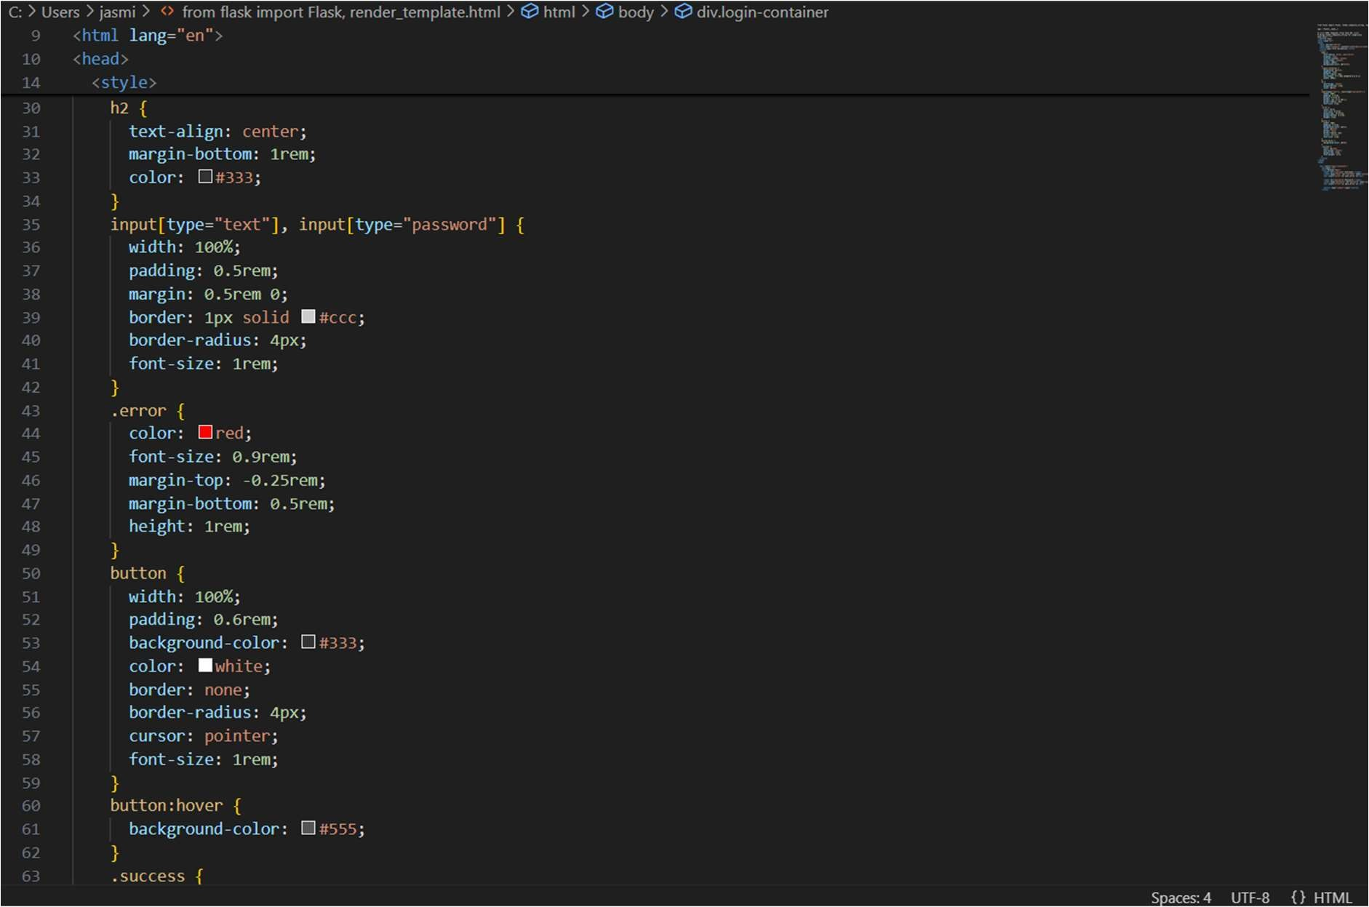

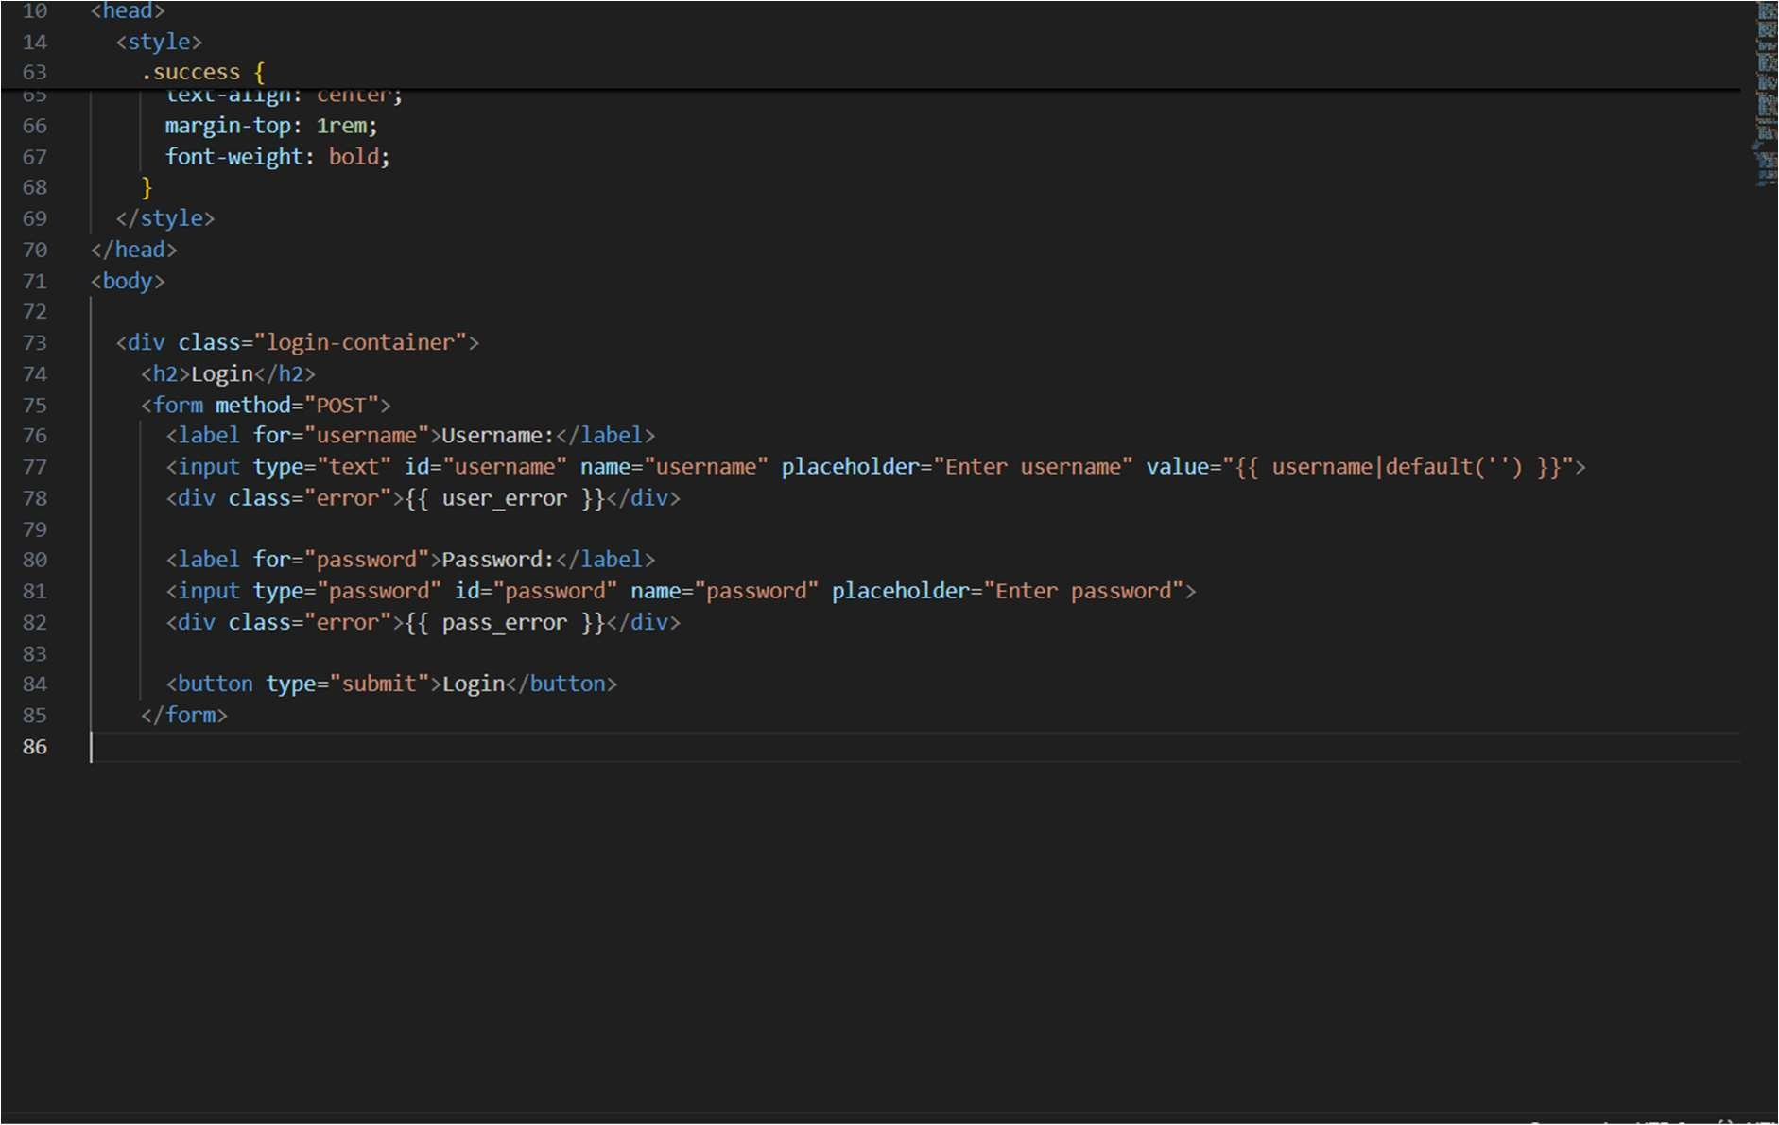

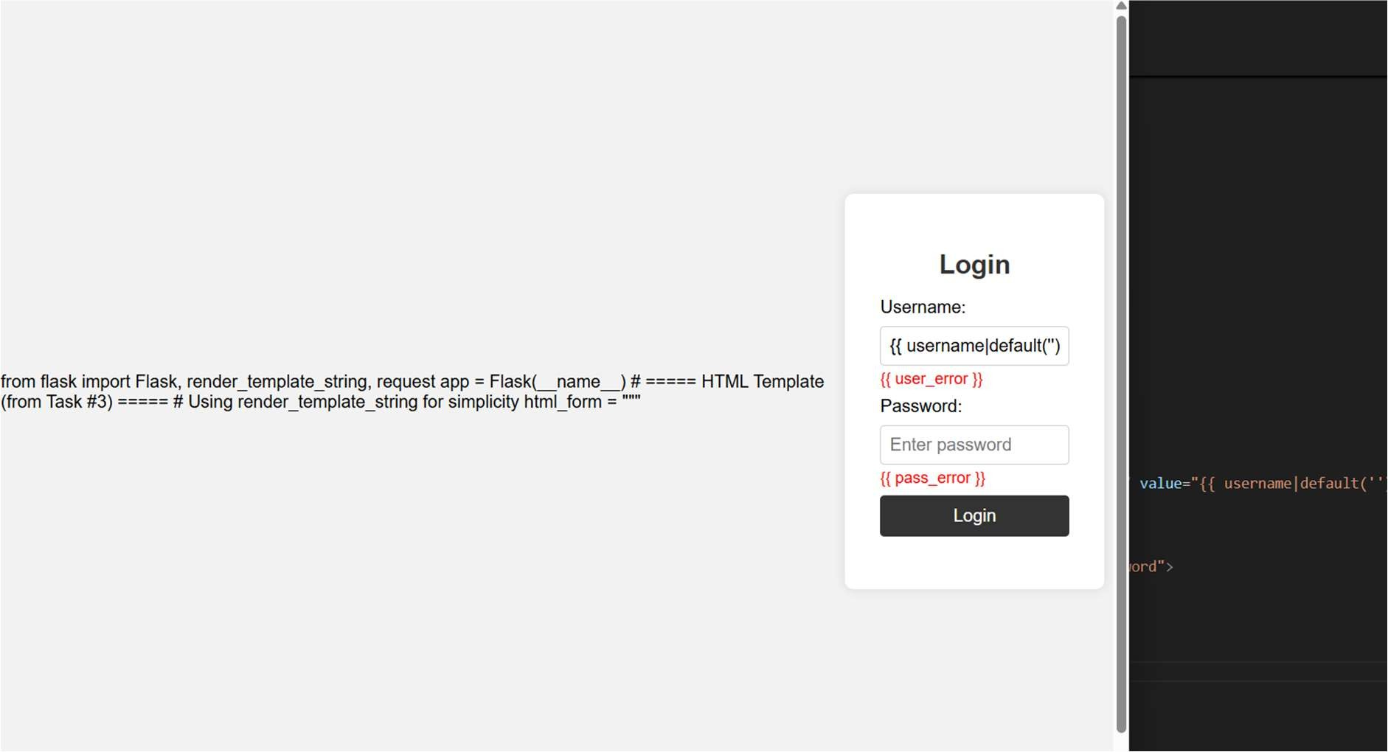

EXPLANATION:

